Module Name: Login Page - Functional & UI Test Case
Test Case ID: TC_LOGIN_001
Webpage URL: https://opensource-demo.orangehrmlive.com/web/index.php/auth/login

Scenario ID: 1A
Scenario: Login with valid credentials
Test Steps:
- Open the OrangeHRM Login page
- Enter a valid username
- Enter a valid password
- Click on Login
Screenshots :
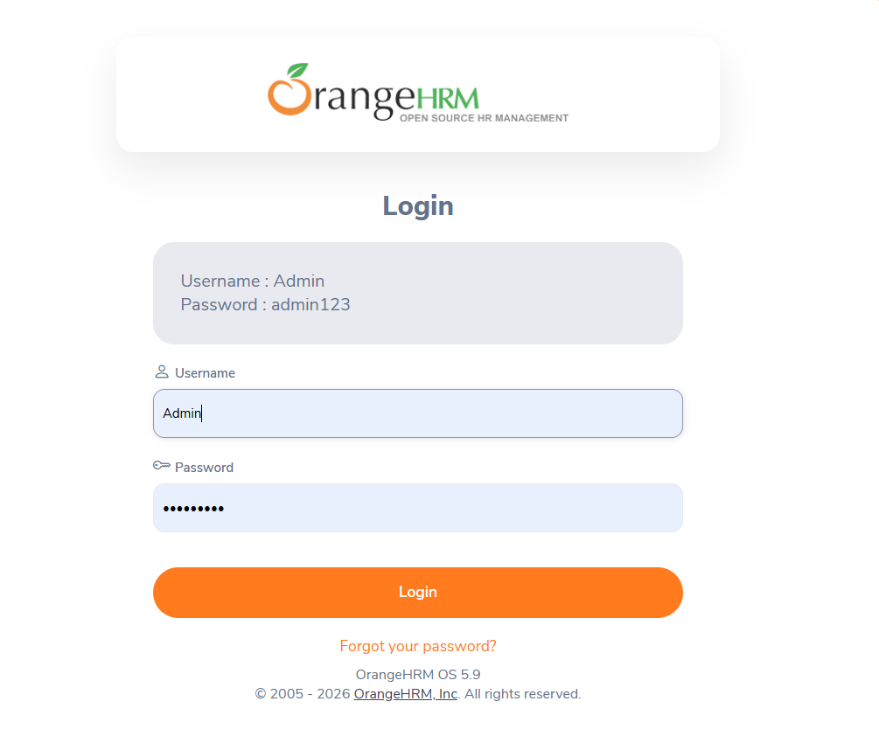

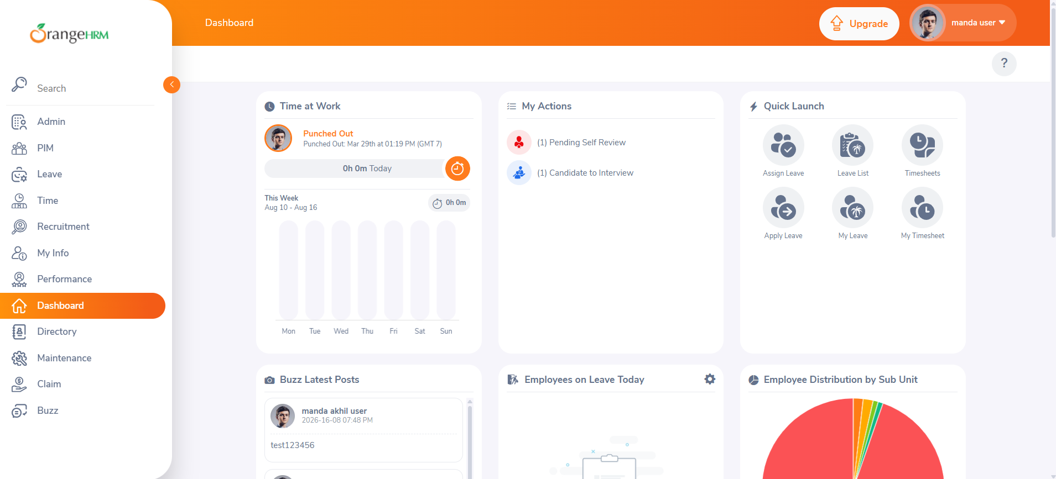

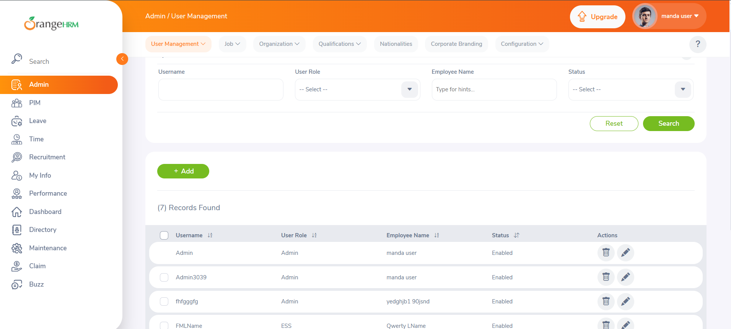

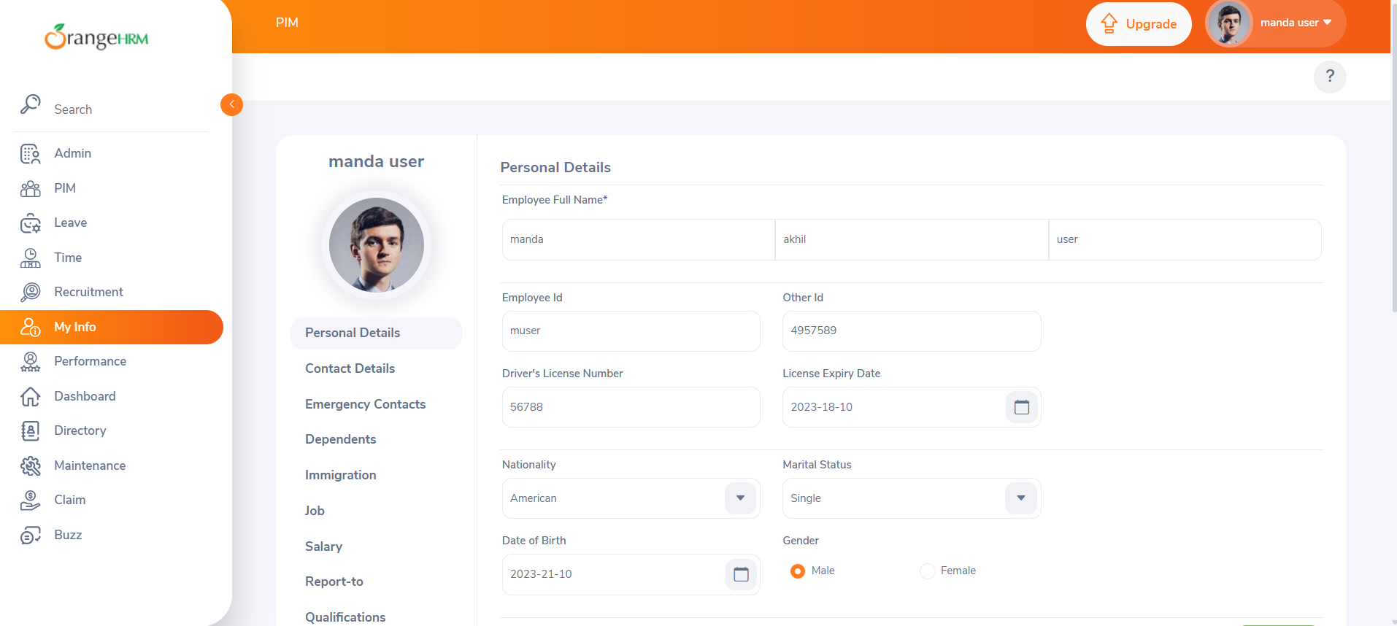

Scenario ID: 1B
Scenario: Login with empty username
Test Steps:
- Open OrangeHRM Login page
- Leave username blank
- Enter correct password
- Click on Login
Screenshots :
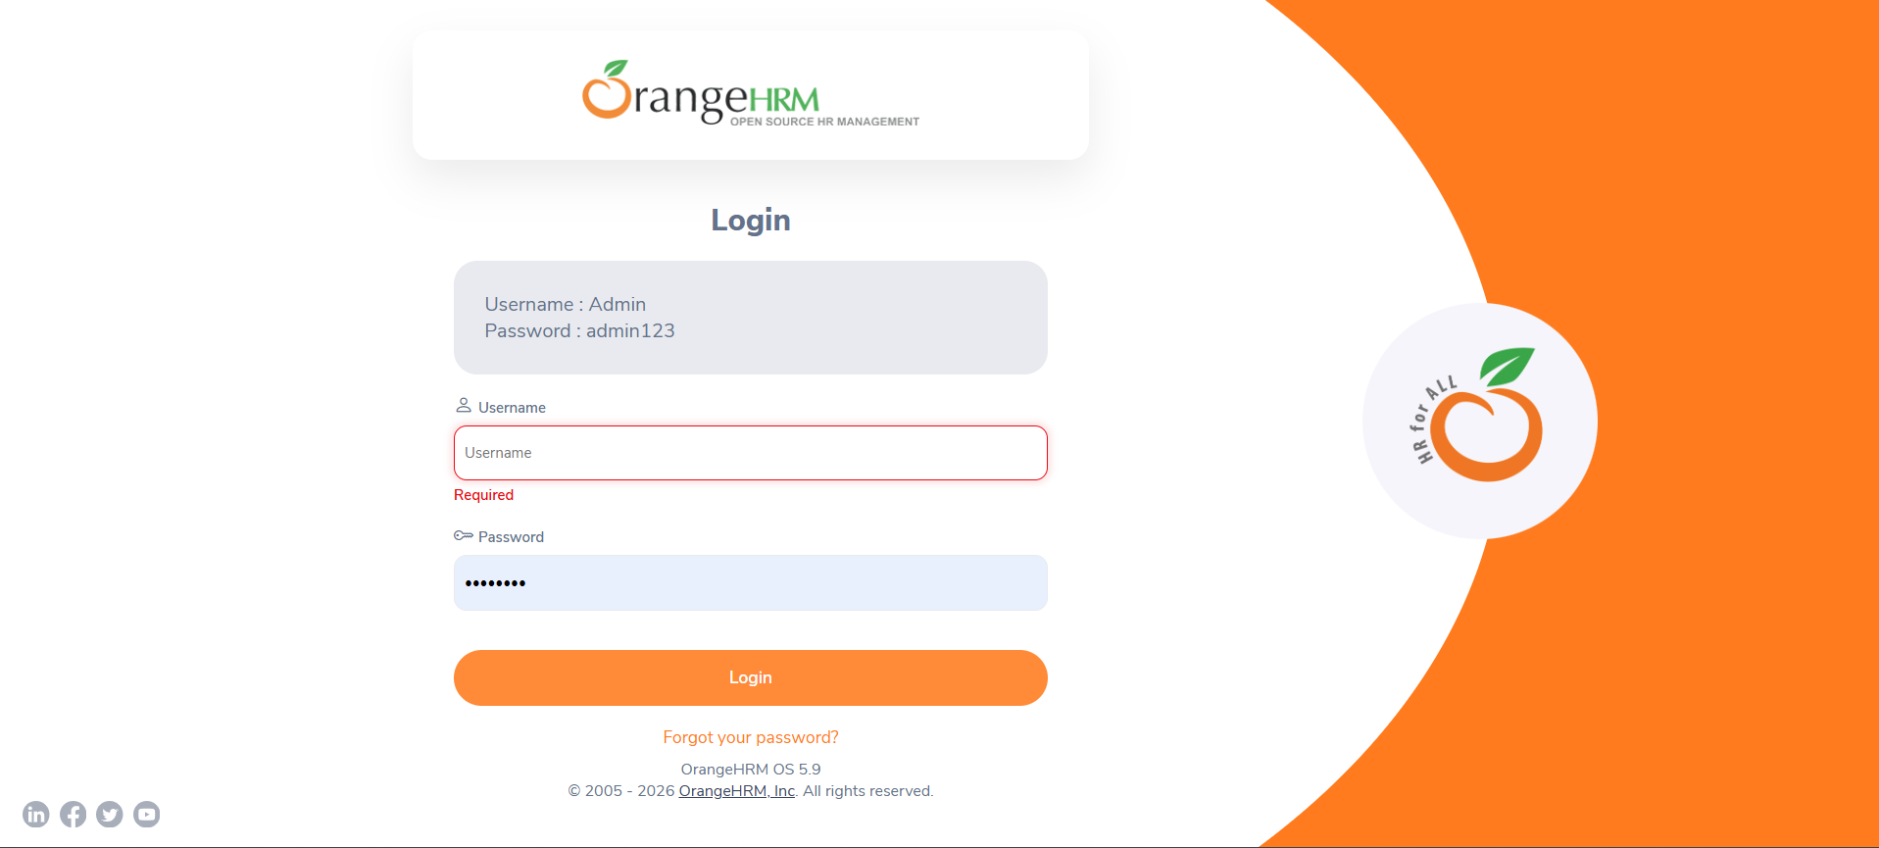

Scenario ID: 1C
Scenario: Login with empty password
Test Steps:
- Open OrangeHRM Login page
- Enter a valid username
- Leave password blank
- Click on Login
Screenshots :
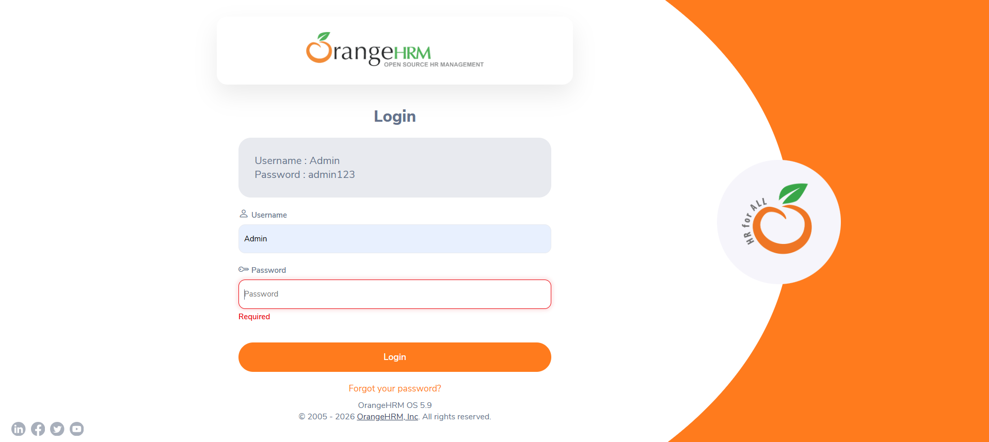

Scenario ID: 1D
Scenario: Login with invalid username
Test Steps:
- Open OrangeHRM Login page
- Enter invalid username
- Enter correct password
- Click on Login
Screenshots :
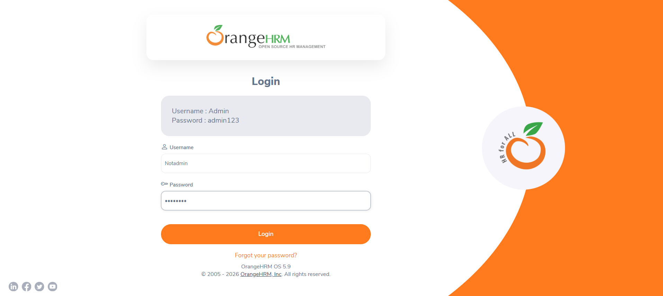

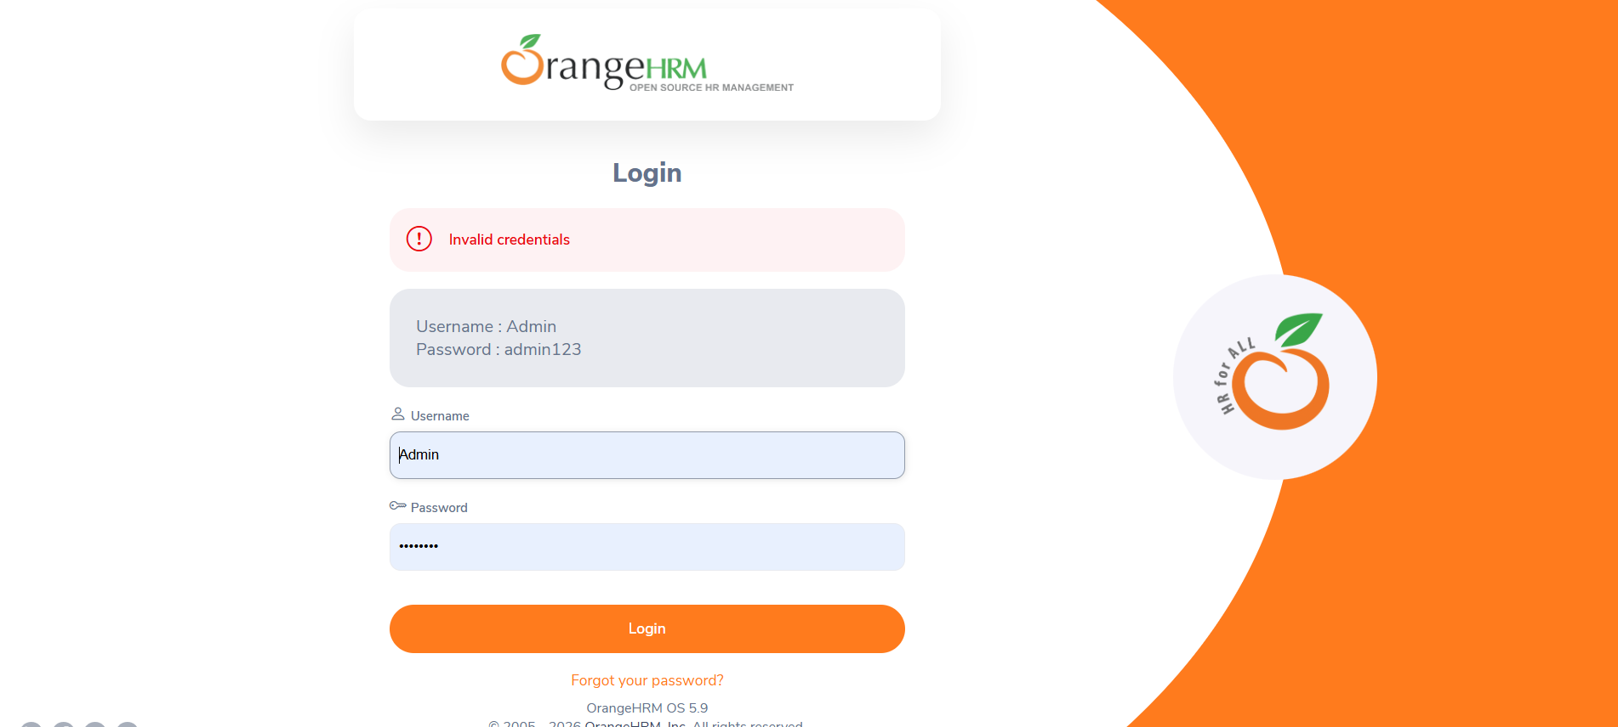

Scenario ID: 1E
Scenario: Login with invalid password
Test Steps:
- Open the OrangeHRM Login page
- Enter a valid username
- Enter an incorrect password
- Click on Login
Screenshots :
